History

From the Beginning till the advanced culture of the great King Minos and their end.

Human life apparently appeared in Greece and Crete as early as in other parts of Europe and Minor Asia. Some findings in Thessaly, Anatolia, Syria and Nil Delta prove that there existed settlements of hunter communities during the early Stone Age. It was a period of abundance; the climate was a little bit warmer than today and there was a huge richness of food. However, from this period, in Greece and Minor Asia just some superficial findings have been found.

Around 9000 BC, the last glaciers of the Ice Age melted and the climate became warmer and more constant. From the 7th century on, it seems to be that the climate was already as the present Mediterranean climate. Especially in Crete, the situation was better than in the rest of the Aegean: numerous valleys gave shelter for the good growing of fruits and plants; the summer heat was moderated by the wind and the winter cold by the proximity of the sea.

The time before the construction of the huge palace of Crete is known as the Early Minoan Period, which compresses the Stone-Copper Age and the late Bronze Age (2800 - 2200 BC). Some forged daggers and elaborated vessels have been found from this period. At the same time, some eastern areas of the Mediterranean gave place to the origin of developed cultures that were somehow related to the Minoan culture. Some of these were the Hellenic culture, the Cycladic culture, and even the Trojan culture according to some sources.

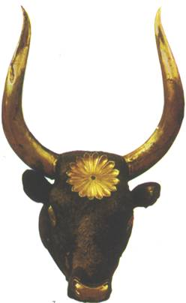
Geographically, the Aegean Bronze Age can be divided into three different parts: the Hellenic one, in the Greek mainland, the Cycladic one, in the Greek islands, and the Minoan one, in Crete.

Around the 2000 BC, right in the middle of the Bronze Age,
Minoan culture started to flourish in Crete. At that time,
the population got together and built the first city. The
fortresses of the early Minoan Age were demolished and
the first constructions of the palace began. The way of
constructing shows that people felt quite safe. The building
s were expensive and they developed a style that used
metal in decoration. Something that could be considered
as the first alphabet was also developed during this time.
This linear-A alphabet was used to list the products of the
harvest and trade, and it consisted of different signs that
were written on a clay tablet.

An important factor in the great wealth that the Cretans
achieved was trade and intermediate trade. In this sector
they took the place of all the other Cyclad Islands. The most active partner was probably Egypt, whose princes got rid of the Greek supremacy around 2200 BC and arranged an own government. In Cyprus, Syria and the rest of the Cyclads there have also been found signs of trade of goods with Crete.

The flourishing of the old middle Minoan palace was the heyday of the island. At this time, the Cretan culture stands out against the other cultures in the Aegean and the Cyclads and develops into one of the high eastern Mediterranean cultures. Around 1700 BC, the Greeks who had been leaving peacefully for many years in the mainland of Minor Asia had to resist the attacks of tribes of riders from the northwest. They had invented the carriages and this set them in a better position in the fights with the Greek. These tribes reached also the Middle East and Egypt destroying a great part of it.

This terrible attacks broke the trade relations of Crete, that had to accept the loss of its main trade partners Syria, Mesopotamia and specially Egypt, and remained isolated. At the same time, this is in 1700 BC, the palaces of Knossos, Phaistos and Mallia were destroyed in a row. The absence of any kind of enemy weapon points to a devastating earthquake that also caused a great damage in other places of the Aegean. The following fires ended up destroying the palace completely.

But already quite after, around 1600 BC in the lately Minoan time the Cretans started to rebuild their palaces and even more, they build Knossos, Phaistos, Tylissos, Gournia and Hagia Triada more beautiful and magnificent, with more elegance and developed architecture. During this time were the most building activities on Crete throughout stimulus and develop of art this time is also said as the golden ages.

The palaces were rebuilt on the ruins of the old ones, and Knossos stood out as the biggest one. It was a three floor high building with an area of more than 20.000 m2.
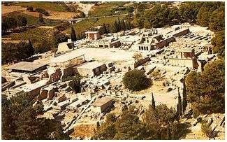
All the palaces didn't had fortifications, it seems to be that the citizen felt quite save, the complex of buildings were build around a central assembly point where more than 30.000 citizens were living. Who was the king at this time you cannot say anymore today, but it is said that the role of the woman was quite developed. They developed also their own letters the linear B scripts and had a big influence not only in the Aegean area, even in north Africa , Mesopotamia till Italy.

Around 1450 BC with the volcanic eruption in Thira or also Santorini, came up the quite quick end of the Cretan culture. It seems it was a really big explosion and drove a huge tidal wave along in front of it, and destroyed the whole Cretan fleet. The sky kept being dark for more than weeks and it was raining ash. All the palaces got destroyed and nearly all also deserted.

In some places like Hagia Triada or also Knossos they found tracks which showed that there was a settlement till 1190 BC. It seems that Knossos was the only palace where remained some more citizens. The Mycenaean's conquered the Island and took over the ruler ship also pirates entered and pillage the island several times between 1300-1200 BC. Since that the Minoan culture is history and never could reach again the glory of the old times. Now it was the time of other cultures, and we will have a look on the mainland of Greece, more precise to the Peleponnese and the Mycenaean's which developed another kind of advanced civilization.

The myth of King Minos.

Minos was a son of Zeus and became the great king of Crete, giving name to the Minoan culture. He had many splendid palaces and a huge fleet that dominated the Aegean Sea for many years. Among the things he did, he dispelled his brother Rhadamnthys from the island, who died soon and went to the land of Hades as a judge.

He had the daughter of Helios, Pasiphae, as a wife. She gave birth to many children, among them to Phaedra and Ariadne.

One day, the sea God Poseidon asked Minos for something more than a regular prayer. He wanted him to make a sacrifice, exactly a white bull. The bull is the coat of arms of Crete, since Zeus was transformed into a bull, and the palaces were completely decorated with horns of bulls. But, where could he find a white bull…? there is not such a thing in Crete. When he told this to Poseidon, the God sent him a white bull from out of the sea.

When Minos found the bull, he liked it so much that he wanted it for himself. Then he though that instead of sacrificing the white one to Poseidon, he could kill an ill bull from his land and keep the white one. So he did. But naturally Poseidon could the trick and took revenge in his own way.

The God made Pasiphae fall in love with the bull and desire the animal desperately. As she didn’t know how to have physical relations with it, she asked for help to the important inventor of the Ancient times Daidalos, who was at that time living in Crete. Daidalos built her then a wooden cow with a hole behind to hide herself inside and approach the white bull.

As a fruit of this relation Pasiphae gave birth to a real monster, the Minotaur. This beast had the body of a person and the head of a bull… a quite hard job for its mother during the birth, and an unavoidable eternal proof of her crude false step. But the Minotaur became a problem itself because it was attacking the people on the street. Again, Daidalos had to find a solution –this time for the king Minos.

Daidalos designed a labyrinth from which it was impossible to go out. After this, the problem was how to feed the Minotaur, because they did not want to kill him but the animal preferred mostly human flesh (and Daidalos could not create humans yet…). Minos was then forced to start a war to get human bodies.
The chosen place was Athens, where he won the battle thanks to Zeus help. From then on, every year the Athenians had to give Minos nine virgins and nine young boys to feed the Minotaur.

Theseus a young hero at this time, could not stand this and left
to Crete to kill the Minotaur. Minos had nothing against this. On
the contrary, he thought that Theseus would never come back
from the labyrinth and that he could then take Athens. But
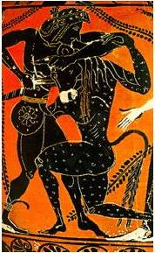
Ariadne got an advice from Daidalos to save Theseus: she would stand outside of the labyrinth holding the end of a threat while Theseus would get in holding the other end. This way, he could manage to find the exit after killing the Minotaur. The plan worked, he killed the beast and returned to Athens. Minos was naturally quite angry and, when he found out that Daidalos had helped his enemy, he closed him and his son Ikaros in the labyrinth.

After a while there were already some birds flying over them
waiting for a good meal. And with so much flying the birds were
loosing some feathers. Some thoughts after Daidalos the inventor was putting together the feathers with the wax of the candles that were standing in a corner of the labyrinth. The result were four big wings that they attached to their bodies, and so they flied away from the labyrinth.

Unfortunately, despite all the warning from his father, Ikaros was so happy with his wings that he flied up, up, up until the son melted his wings. The boy fell somewhere in the Aegean and got buried in an island that got named after him: Ikaria. Daidalos continued his way and arrived to Sicily, where the king Kokalos warmly welcomed him.

But Minos had not forgiven him, and he published an enigma to try to catch Daidalos. Of course, just Kokalos could answer it, so Minos knew where the inventor was hiding. Therefore he left to Sicily with a big war fleet, but before he could capture him, the daughter of Kokalos scalded him when he was having a bath and he died. This was the end of the Minoan rule and the so-called Minoan culture.

Athens-the first democracy and the rule; Persian wars and the decline by Sparta.

Prehistoric Athens is not to compare with the size of Athens of today, the same as for all ancient cities. Around 600 BC Athens had 15000 Inhabitants in the whole catchment's area; the district of Attica had around 150.000 Inhabitants. Most of them were farmers occupied with agriculture and settled down all along the coast of Attica. The area of Attica at this time comes to a size around 2600km2.

Before 600 BC Athens was ruled by individual rich noble families, who were only interested in maintaining and enlarging their power (Tyrants). Around 600 BC, through impoverishment of the general middle class and social and economical changes, the demand for fundamental changes came about. In this situation 594 BC, the Athenian Solon got elected as the head of the government and came up with a plan to change these miserable circumstances.
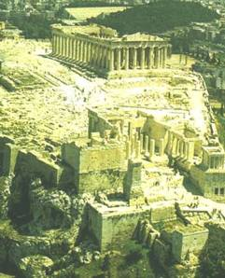
His plan was a new distribution structure of the
political rights and duties. The standard of the
political participation shouldn't be longer the origin of everyone's (till now just noble could vote), but the fortune of everyone's. The Inhabitant of Athens got classified in four financial groups, depending on their income. For sure this wasn't a democracy, even if its said later that Solon is the founder of it. The national
assembly (Ekklesia) and the People's Court (Helia) were from now on accessible for everybody. The elections for the council of 400 were still depending of the income.

Many things got subjugated to new rules. Some were completely new, some remained the same and others got adapted. The important was that all this rules were written down and got published, so that everybody could refer to it. And still it wasn't a democracy but at least non noble people, even if they were just rich people, had access to politics.

Kleisthenes' Reforms

One of the most important turning-points in the history of Athens was the taking of the power by Kleisthenes in 508 b.c. and his introduction of new regulations. According to these, the right of the citizens to take part in politic matters stopped being divided in Tribes and Brotherhoods; now it would be divided following pure territorial principles.

Attica got divided in ten political districts out of this three regions:
the city, the coast, and the inland.

However, the main item of the new reform was the new council. The council was composed of 50 members from each of the 10 political districts, 500 members in total. At the beginning, not many tasks were entrusted to the council, but this changed during the 5th century. Later, the council was responsible for the financial control and the guarding of the official posts. Furthermore, without the positive vote of the council, the assembly could not make any decision. Any candidate suspected of planning a tyranny or of using politics for an own profit could be banished for 10 years through an ostracism if at least 200 of the 500 members voted against him.

Although the council represented the people, the highest posts were still under the control of the wealthy class. This means just that the rich people could be elected for one of the nine Archonten. The first Archon, after whom the official year was named, had public duties. The Basileus (president) was responsible for the cultural matters. The Polemarchos (commander) was the responsible for the military supreme command. The sixth other Archonten, the Thesmothetai, were judges and took care of the executive functions in the city.

Also the Areopag did not change for the present. It was the upper court and controlled all the official posts in the city. The 200 - 300 members were former Archonten and were chosen for life. At the beginning, also just the nobles had access to these posts. In fact, the city stayed for quite a long time in the hands of the nobility, although with the agreement of the people.

The Persians

499 BC the Greek cities in Ionian (Minor Asia) got besieged of the Persians and asked help from Athens. Athens troops pushed 498 BC forward till Sardes, but then near Ephesus they got defeated totally and pulled back to Athens.
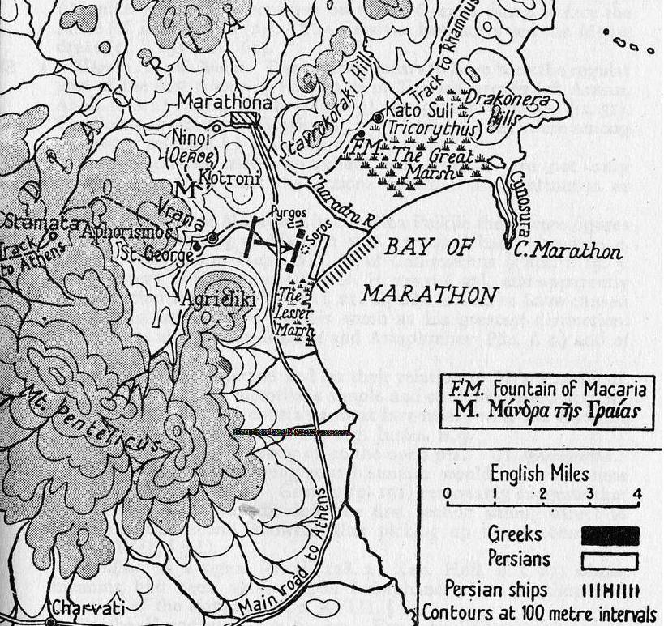
Like this started also the conflict between Athens and the Persians, which never forgot them for the support to the Ionian cities.

In 484 BC the successor of the King of Persia
Dareios, Xerxes, started the preparations for
another huge attack on Greece. As a result,
Corinth, Sparta and Athens signed the Anti-Persian Alliance or Hellenic Alliance under the leadership of Sparta.

In 480 BC, the Persians attacked again and
defeated Leonides' troops in the first battle in the North of Greece, near Thermopiles, clearing like this their way down to Attica. As soon as they knew it, the Athenians decided to leave their homes and everything behind them to clear the whole region of Attica. They would go to the strait of Salamina to give the decisive battle. The Persian burned down almost all Athens and, what still remained standing, got destroyed on their way back from Boethia. However, in the strait the agile ships from Athens had better cards than the Persians and soon put them on the flight. These returned then to the north of Greece, where they suffered another terrible defeat. The fights in the Plataion plains under the leadership of the Spartan Pausanias went on for some weeks. At the same time, a Greek naval unit defeated the rest of the Persian army in Mykale, the peninsula opposite to Samos, definitively finishing with the Persian danger.

After the victory, the opinion of the members of the Hellenic Alliance were completely different. The Spartans wanted to return to the mainland and to stop their activities in Minor Asia. The Athenians felt really encouraged and offered themselves to protect the cities of Minor Asia. These were the seeds of the future naval alliance of Attica that would be the basis of the great power achieved by Athens in the 5th century BC. In 479/80 BC, the Athenian built a wall around Piraeus and Athens without the approval of Sparta originating the first of the disputes between both cities.

The Peloponnesian War

During a long time discrepancy reigned between the big powers Sparta and Athens. Athens was expanding his power steadily since long ago and infringing once and again the 30 years old peace agreement. The decisive action that started the war was the claim of the Athenians of the demolition of the traditional relation between Chalkidike and Corinth, together with the simultaneous shutting of all the ports of the Attic Alliance to the ships from the city Megara.

Because of this, all the partners of the Alliance pushed the Spartans to war against the Athenian tyranny, which started officially in 432 BC leaded by Sparta. The political power of Athens had many enemies, since towns were still forced to pay the contribution of the Alliance. The result was the blocking by Athens of the channels of distribution of the Spartans and the evacuation of all Attica.

From 431 to 425 BC, the troops from the Peloponnesus invaded Attica every year at harvest time. In 430/29, a plague killed around one third of the population of Athens, which could still manage to fight in Sicily and central Greece without much success. In spring of 421 the war got to an end with a kind of draw and the so-called peace of Nikia, which duration was limited to 50 years and contained a common defensive alliance.

However, the piece did not last long and, after new attacks from Athens against the Spartan sovereign territory in 414 BC, the Spartans took up again their yearly attacks. A political commotion seized Athens and democracy was put out of action for a couple of years until 410 BC. In the year 405 BC the whole fleet of Athens, devastating in Aigogospotamer, got completely exterminated by the Spartans. At the same time, many colonies in Athens were violently dissolved and its channels of distribution got cut off.

The Spartan siege ended in 404 BC with the total surrender of Athens. Sparta established then a transition government composed by 30 members that turned out to be a terror system where many encountered their death.

The claim of Macedonia

Macedonia was situated on the Greek ancient world, they were speaking a Greek dialect, but the culture development was along time a little way away and a little behind. Unlike the rest of Greece, they didn't formed city communities, huge pieces of land were owned by noble’s families. In the 5 century BC the Kings of these lands tried to get in contact with the Greek world and Alexander was the first noble who achieve the acceptance of his house as Greek. His successors Archelaos extended the infrastructure, build streets and fortresses and invited Greek artist and poets in his land.

After the dead of Archelaos came up confusing situations and several power struggles, which ended 359 BC with the seizure of power by the just 24 years old Phillip II. He managed to eliminate his opponents and he could bundle up all the individual nobles to a united Macedonian State. In his youth Phillip was taken away from the Thebans as a hostage and learned there some military strategies, he used now to rise up Macedonia to a outstanding military power. He bought mercenaries, arranged the Phalanx in a deeper stagger, build up huge cavalry regiment and developed different strategies of siege.

He conquered Amphipolis, Rydna and Poteidaia what ended in a war with Athens, which saw their interest in those areas in danger. At the same time, during the 3rd Holy war around the year 356 BC, the Phoker were, with the support of Athens, in the area of Delphi, and during a while they had whole central Greece under control. Boeotia and Thessalia called Phillip for help and he pushed, 352 BC the Phoker out of Thessalia and just kept the new land for himself.

He provoked 349 BC a war with Olynth and the Chalcidician Alliance, which ended up in the totally destruction of Olynth and the connection of the region to the Macedonian Empire.
In 346 BC Athens and Phillip made piece. He also arranged with Artaxerxes a non-aggression pact, with the goal to be save from the northern front line and in the same time to connect Thrace to his Empire. In 338 BC, in the fourth Holy war Phillip provoked, he defeated Athens and captured central Greece. In the deciding battle near Chaironeia in Boeotien he won and got the ruler ship also for Lemnos, Imbros, Skyros, Samos and Delos.

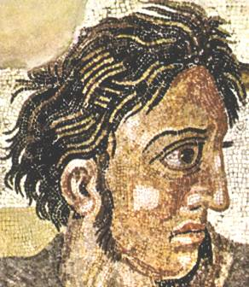
He also impose restrictions on Sparta and founded 337 BC the Corinthian Alliance. The members had to respect all member states, their borders and had to accept the same friends and enemies. Phillip didn't become a member but made assure that he would have the chairmanship lifelong. He invented this alliance on purpose to extant his Empire to the east, an attack on Persian. After the Death of Artaxerxes II, 338 BC, in 336 BC the successor Dareios III took the power, and in the same year 10.000 Macedonian soldiers crossed the Hellespont.

But Phillip couldn't realized his further plans, he got killed by a noble in 336 BC, during a wedding ceremony. However he managed all prerequisite for his son to continue his plans of a huge Macedonian Empire.

Alexander III “the Great”

Alexander got enough support of the Macedonian nobility and with 20 years he became established as the King of Macedonia. As there's a rumour going round that Alexander died, the Thebans started 335 b.c. a rebellion against Macedonia, which ended quite quick with the totally destruction of the city and the enslavement of their inhabitants.

334 b.c. Alexander III passed the Hellespont, defeated the Satraps and captured the whole territory of Minor Asia. In every district he appointed Macedonian ruler. He moved on to Kilician, where he fought in Issos 333 b.c. the first big battle against the Persian king Dareios III, defeat him and put him to flight. After month of siege he also took over Tyros and Gaza and conquered peaceful Egypt. 331 b.c. He founded Alexandria in Egypt and in the same year he moved forward till north of Mesopotamia. Near Gangamela he defeated a second time the Persian King Dareios III and occupied Babylonia, Susa, Persepolis and Elebetana. Soon after, Dareios got killed from his own followers.

Alexander the Great moved on with his troops till to the borders of nowadays Afghanistan, Turkmenistan, Tadschikistan und Uzbekistan. He founded another Alexandria Basra near where the river Euphrates flows in the Persian Golf. He married Roxan a sogdian noble. He integrates more Iranian and took over Persian customs. In 327 v.Chr. his campaign to India started. On their way they defeated several Indian royal houses, but as they arrived to the Indian river Hyphasis and couldn't see an end, the army refused to continue. Alexander leaded the troops with a new built fleet down the Indus where they arrived 325 b.c. near Pattala to the Indian Ocean. Here they formed two groups, to return on different ways back to Babylonia. The first group went through Archosien, an other group moved further with the boat to nowadays Kuwait, where the river Euphrat flews and the third group with the leadership of Alexander reconnoitre the deserts of Gedrosiens, nowadays Belutschistan.
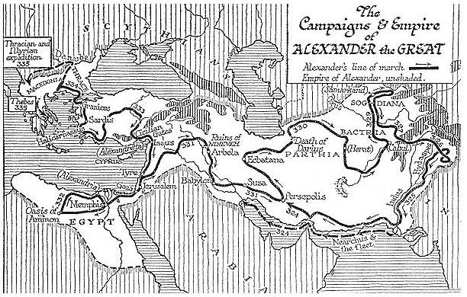

As Alexander returned to Babylonia, some of his district rulers set up on their own and escaped now. In 331 b.c. Antipatros the ruler of the European part had to suppress a revolt of Sparta and an alliance of some other parts of Peloponnesus, what succeeded in 324 b.c. At the same time broke out a mob of the troops in Opis near the Tigris which Alexander suppressed with determination and severity quite quick.
The capital of his empire should have been Babylonia, but everything turned out quite differently. Alexander felt ill and died 323.b.c. with fever in an age of 33 years old in Babylonia. If he could have kept his empire with this size for a long time its difficult to imagine, I have my doubts. But he respected from the beginning local traditions and political structures. He organized marriages between Macedonian district rulers and Iranian women’s und just occupied important political and military positions with Macedonians.

